FPT ACADMY INTERNATION
FPT-APTECH
--o0o--



Project Report

Patient Info System
Students’ name (code on eProject Guide):
- Duong Van Tung
- Nguyen Ngoc Thien
- Nguyen Van Hinh
- Do Duy tung

Leader’s email: Tungdv_a05020@fpt.aptech.ac.vn
Faculty: Nguyen Tuan
HaNoi 8/2012

HANOI 08-2009

User Manual
- Login

Login Adminsitrator and User

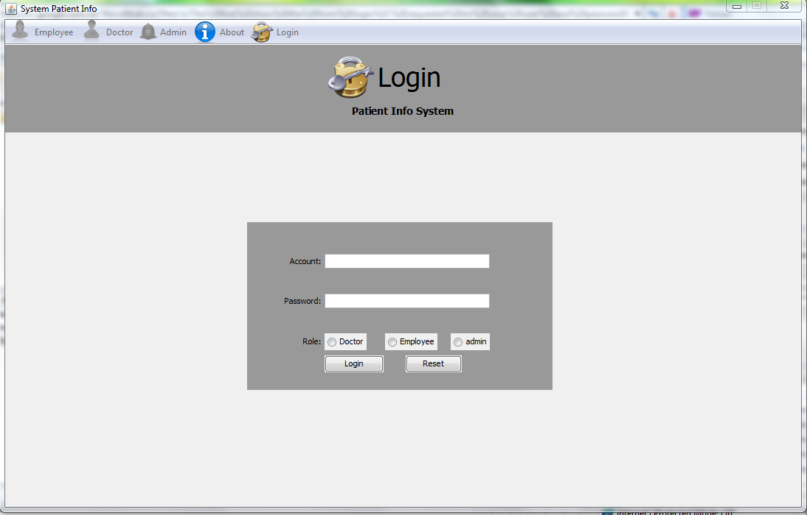

The first show the form login, requested on your user and password, check the validity of the user and password, if it is not a valid request to re-enter, if a valid check to the right users and administrators

Home

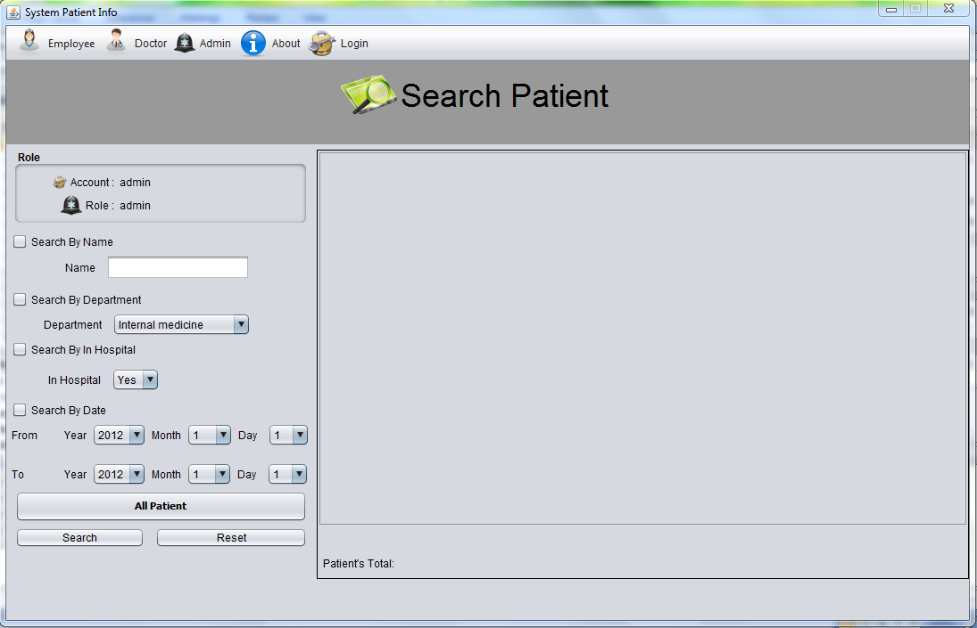

- Patient
- Create a New Patient:
- Click the Employee button on the toolbar chose Add Patient
- Enter information in the text boxes.Use the Tab key to move from box to box.
- Click the Add button to save the record
- Click the reset buttom to reset the record.

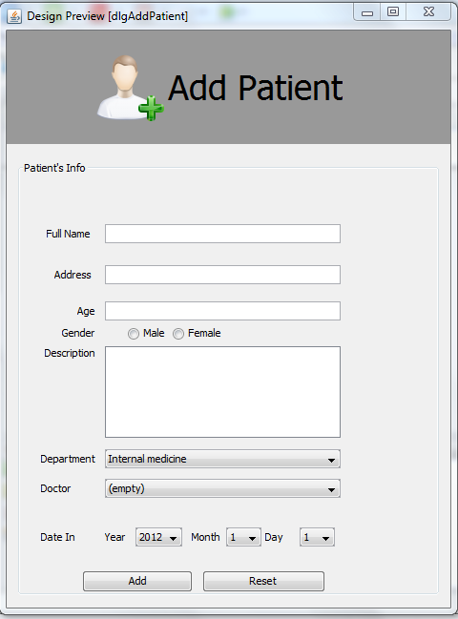

- View List Patient Information And Search:
- Click the Employee button on the toolbar chose Patient’s Information
- Enter information in the text boxes.User the Tab key to move from box to box.
- Click the Search butom.

- View Patient Details And Update Patient Information
- Select a Patient in the viewer.
- Enter information in the text boxes.Use the Tab key to move from box to box.
- Click the Update and Delete Patient buttom to save the record.

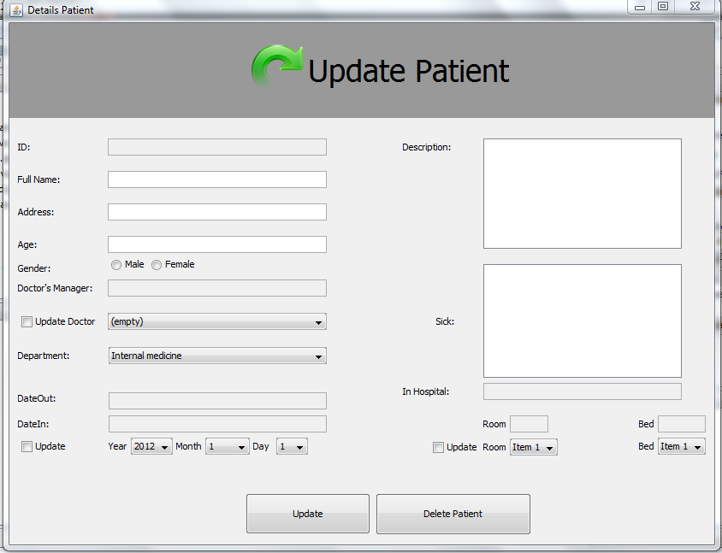

- Function Treament:
- Click the Doctor button on the toobar.

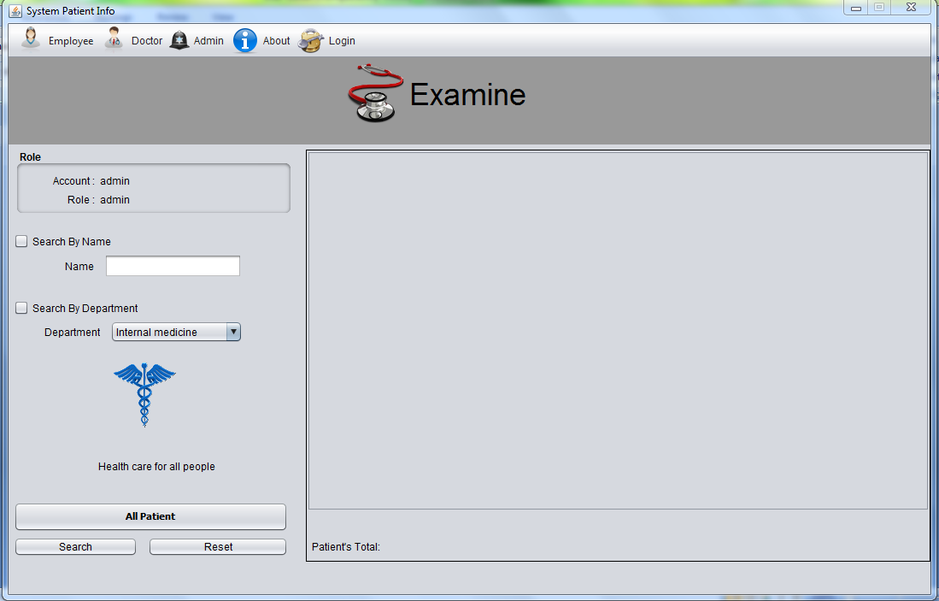

- Function Change Treatment:
- Click the Doctor button on the tabbar chose Examine.
- Enter information in the text boxes.User the Tab key to move from box to box.

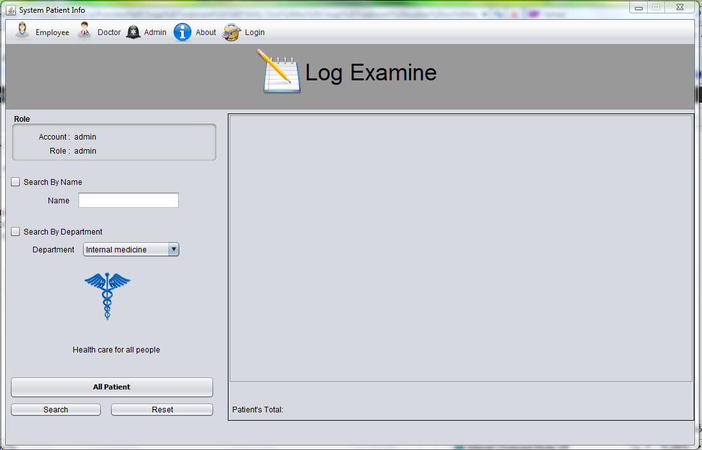

- Function Out Patient:
- Click the Doctor button on the tabbar chose Examine.
- Enter information in the text boxes.User the Tab key to move from box to box.

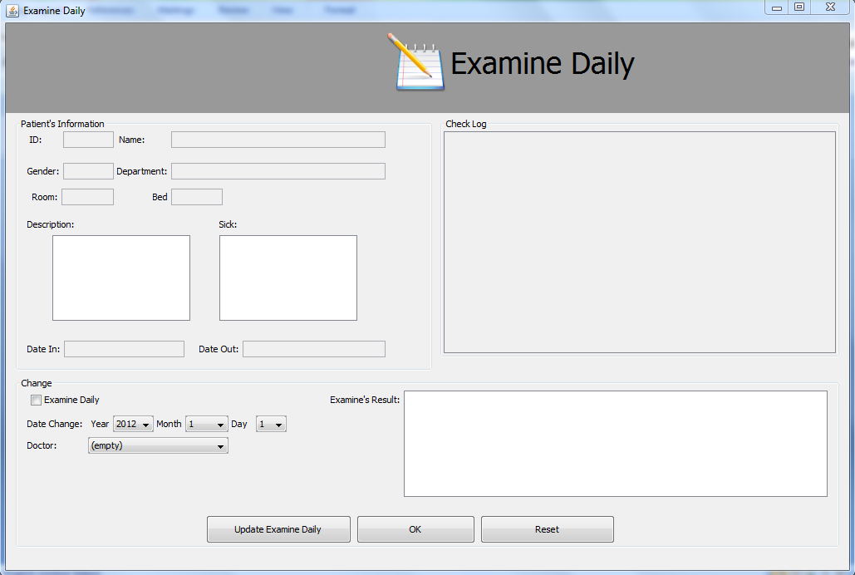

- Doctor.
- Create anew
- Click the Admin buttom on the toolbar chose Add Doctor.
- Enter information in the text boxes.Use the Tab key to move from box to box.
- Click the Add button to save the record.
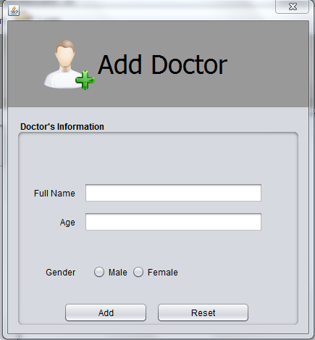

- Account
- Create a new Account:
- Click the Admin button on the toolbar chose Add Account.
- Enter information in the text boxes.Use the Tab key to move from box to box.
- Click the Add button to save the record.
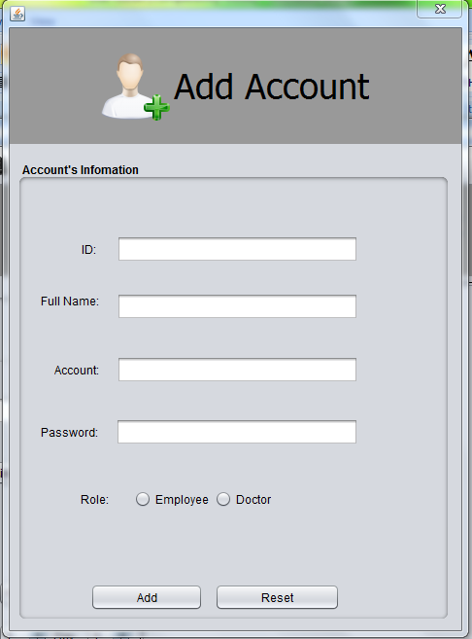

- Change Password:
- Click the Change Password button
- Enter informaition in the text boxes.User the Tab key to move from box to box.
- Click the Ok button to save the record

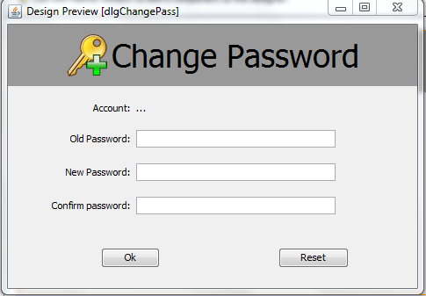

- ADD Bed
- Click the Admin button on the toolbar chose dlgAddRoom_Bed buttom.
- Click the buttom to chose function.
